**Water-Soil-Sediment Chemistry Data Reporting Format Instructions**

To create a data package containing chemical concentration data for water/soil/sediment samples follow these steps:

1. **Decide how you want to organize your data** – for example: one or more data files?, samples in rows or columns?, one or more measured variables in one data file – if more than one, in rows or columns?, method metadata details in the same or a separate file? ***We strongly recommend using separate files for the data and the detailed method metadata, as it will simplify reuse of your method metadata across data packages.*** It also makes the data table easier to overview.
2. **Create your sample metadata file(s).** Make sure all of your samples have a unique name and assemble the sample metadata table, following the instructions for sample metadata.
3. **Assemble the data table(s)**, making sure that all of the required fields are included and formatted correctly (see example) and that the Sample_Names and Material fields match the ones in the sample metadata file. ***NO empty rows or cells are allowed; use “-9999” for missing values in numerical fields and “N/A” in text fields - this includes header columns and rows.*** Using the data_template is strongly recommended. Note that header rows can be turned into columns and vice versa if that is more suitable for your data (see example). It is also permitted to record the required metadata for each measured variable in the data dictionary (_dd.csv) file as long as all required fields are included.
4. **Assemble the methods file** (methods_template), making sure all of the required fields are included and formatted correctly. All method descriptions must be detailed enough for someone else to repeat the procedure. It is recommended to use separate columns for details that are of relevance for making quick assessments about sample integrity, method applicability, and data quality (e.g., temperature, light, atmosphere conditions). See example.
5. **(Optional) Prepare terminology file** (template)**.** If you are using data flags or other codes (that are not Field_Names, methodIDs, or Sample_Names included with corresponding required metadata in data dictionary, method, or sample metadata file(s)) you must provide explanations for those in a separate terminology file (see example) or add them to the data dictionary (including a column for the required “Term_Type”) (see example). We recommend assembling all terms and codes that are used within your project in one “master” terminology file, which can then be included in its entirety in all data packages or used to create a data package specific terminology file with a subset of the relevant terms for that data package. This will help maintain consistent terminology within the project (e.g., between team members or subprojects) and will minimize time spent on generating terminology and data dictionary files for future data package submissions.
6. **Save all files to be included in the data package in csv format** with the appropriate extension (*i.e.*, _data.csv; _methods.csv; _terminology.csv; _dd.csv). Filenames must be unique and should be as descriptive as possible about the file contents (e.g., 2018_SlateRiver_soil_data.csv; WHONDRS_methods.csv; WatershedFunctionSFA_terminology.csv). **Use only letters (e.g., camelCase), numbers, and underscores "_"**. Do not include spaces. Hyphens are allowed but not preferred. No other special characters are allowed in file names.
7. **List all terms (Field_Names) in data dictionary table(s)** (template) - [fileName_dd.csv], providing the required metadata for csv files (see example). Note that even if units are included in the data file (recommended), it is still required to specify the unit for each variable in the data dictionary. You may create a _dd.csv file for each individual file, or use the wildcard “*” option and generate one _dd.csv for multiple (or all) files in the data package (e.g., if the same data dictionary is used for multiple groundwater sample concentration data files you may use “groundwater_chem_*_dd.csv”). It is recommended to keep methods and terminology data dictionaries separate from each other and from those for data files, as the structures are different between those types of files. However, if you follow the recommendation of generating one master methods file and one master terminology file, you should be able to re-use the same data dictionary for each of those for future data packages (unless there are terminology or methodology changes for your project). You should also be able to assemble the data dictionaries from the master terminology file by copying and pasting the relevant terms for the specific files. The data dictionary is a requirement for all csv files according to the file level metadata reporting format and is needed to make translation and combination of data from various projects and packages possible for others and to facilitate the automatic extraction of file level metadata (i.e., saving time and effort for you).
8. **Assemble the file level metadata (FLMD) table for all files in your data package** (template) Note that all files included in a data package must be listed in the FLMD table.

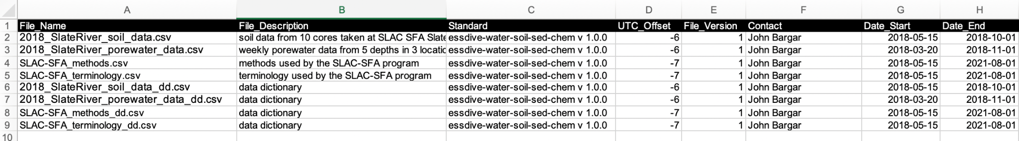

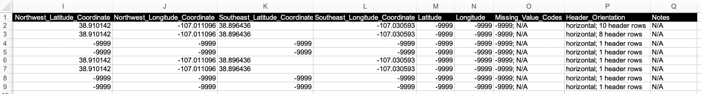

**Figure 1.** Example of FLMD table for a data package with two data files from SLAC SFA 2018 field campaign at Slate River, CO. *Top:* Columns A-H, *Bottom:* Columns I-Q.